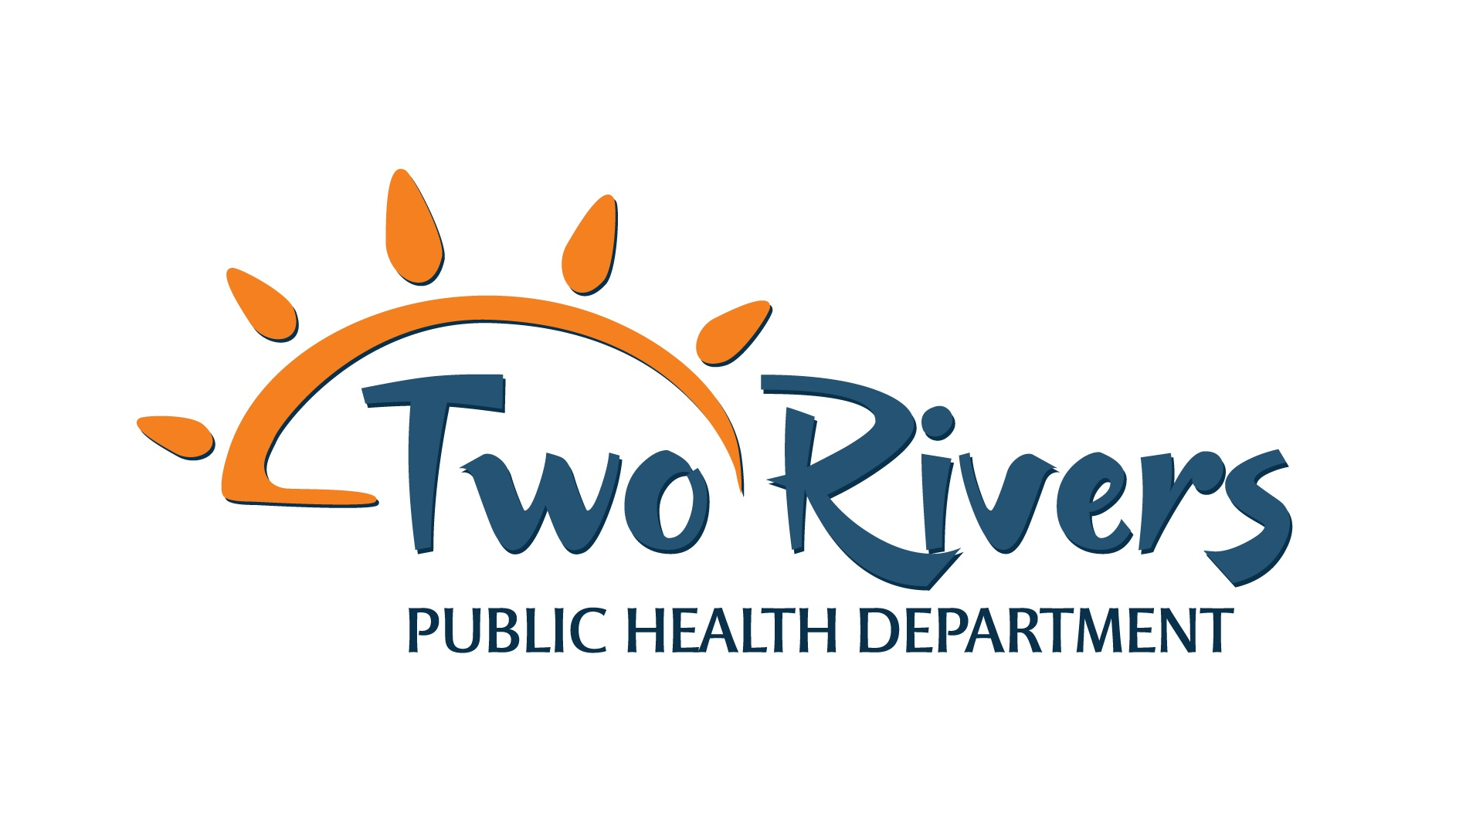
Environmental Health Specialist Job Description

Job Title: Environmental Health Specialist
Revised Date: April 9th, 2025
Reports to: Environmental Health Supervisor
Scope of Authority: Employee is not responsible for supervising other personnel.
Security/Access: Employee will be issued picture identification with electronic access capability and department credit card.
Job Summary: Responsible for developing, implementing, coordinating, and evaluating effective environmental programs and education.

Required Education and Experience:
- Graduation from an accredited college or university with a bachelor’s degree in Biological Sciences, Chemistry, Environmental Sciences, Public Health or a closely related field
  - Degrees must include 30 semester hours of college credit in basic science coursework and credits for a college-level math or statistics course. Basic sciences include life, natural, physical, and health sciences.
- Certification as a National Environmental Health Association Registered Environmental Health Specialist. Will achieve Nebraska certification of Registered/Provisional Environmental Health Specialist within 180 days of employment.
- National Incident Management System (NIMS) compliant within 180 days of employment. Training is provided.
- Proficient in Microsoft Office computer applications and database applications.
- Ability to operate standard office equipment including but not limited to computers, printers, copiers, scanners, calculators, facsimile machines, and multi-line telephone systems.
- Must possess and maintain a valid Nebraska driver’s license and provide proof of personal driver’s insurance. Ability to operate organization fleet vehicles and utilize own transportation for work purposes as necessary.
- Ability to travel within the TRPHD seven-county service area. Further distances on occasion.
- Ability to work well with diverse groups in the public sector and demonstrate cultural awareness and sensitivity.
Duties and Responsibilities:
Enforce laws and regulations passed by the Board of Health, local municipalities, State of Nebraska, and other entities that protect health and ensure safety.
- May be designated as the primary, secondary, or tertiary Emergency Response Coordinator, who facilitates collaborations with key stakeholders to enlist public health services in emergency situations. Plan, schedule and participate in necessary exercises with identified entities, develop internal drills and emergency response trainings, and complete other workplan items as delegated.
- Conduct regulatory inspections to enforce public health standards; document findings appropriately and collaborate with state and local partners to ensure timely communication and follow-up of violations.
- Investigate and document environmental complaints, contact appropriate agencies for help or referrals, and provide recommendations or follow-up per organization procedures.
- Monitor and track the surveillance of environmental health issues/diseases: i.e., West Nile Virus, lake algae, public health water violations, etc.
- Inform, educate, and empower citizens about environmental health issues such as radon, lead, mercury, pharmaceutical disposal, mold mitigation, indoor air quality and other issues that impact the communities.
- Develop, promote, conduct, and evaluate new and innovative department programs, education, and activities as well as strategies to increase participation in the programs.
- Has knowledge of disease prevention, health promotion, prevention and lifestyle risk reduction education, current public health problems, and organizations that deal with those problems.
- Demonstrates sound fiscal accountability.
- Search for funding opportunities and develop, submit, and implement grants, budgets, and contracts with various funders.
- Comply with work plans, reporting requirements, and timelines per grant and/or contracts in an accurate and timely manner.
- Compliance with all TRPHD policies and procedures.
- Participation in assigned internal staff committees.
- Participation in required TRPHD training.
- Participate in performance management, activities to sustain a culture of QI within TRPHD and department accreditation efforts.
- Maintain strict confidentiality of sensitive information in accordance with department confidentiality and HIPAA regulations.
- Able to work some evenings and weekends as needed.
- Professionally represent TRPHD when out in the community in a variety of settings.
- Assist with emergency response efforts to disease outbreaks and/or disasters when requested.
- Participate in media interviews.
- Operate and maintain specialized environmental sampling and testing equipment.
- Evaluate training courses and seminars about environmental health issues to educate the public and to promote compliance with environmental laws, regulations, and programs.
- Develop information and information systems to provide the most current information concerning environmental health risks and environmental biotechnology to the public, industry, and other governmental agencies.
- Educate the public regarding environmental issues; provide advice and resolve challenges associated with sanitary standards in food, water supply, garbage disposal, sewage disposal, and housing maintenance.
- Other duties as assigned.

Basic Skills and Abilities required:
- Ability to establish and maintain effective working relationships with coworkers, administrative support organization, elected and appointed officials, representatives of other governmental units, private industry and members of the general public.
- Readily assume responsibility.
- Ability to communicate effectively and articulate both orally and in writing.
- Ability to think strategically.
- Ability to organize, analyze, and interpret technical information.
- Ability to organize tasks, establish priorities and meet established deadlines.
- Ability to exercise objective judgment.
- Ability to sit, walk, stand and drive; use hands, fingers to handle or feel; reach with hands and arms; and talk and hear. The employee is occasionally required to stand, climb stairs, walk, stoop, kneel, crouch or crawl. The employee must be able to lift and/or move 50 pounds. Specific vision abilities required include those of close vision, distance vision, peripheral vision, depth perception and ability to adjust focus. The employee must be able to demonstrate physical fitness activities.
- Ability to work in a smoke/tobacco-free and drug-free work environment.

This position qualifies for non-exempt status as defined in the Fair Labor Standards.

The position of Environmental Health Specialist requires 30-day notice of resignation.

I have read the above job description and agree to carry out the responsibilities described therein.

Signed: _______________________________________________ Date: ___________________

Director: _______________________________________________ Date: __________________

