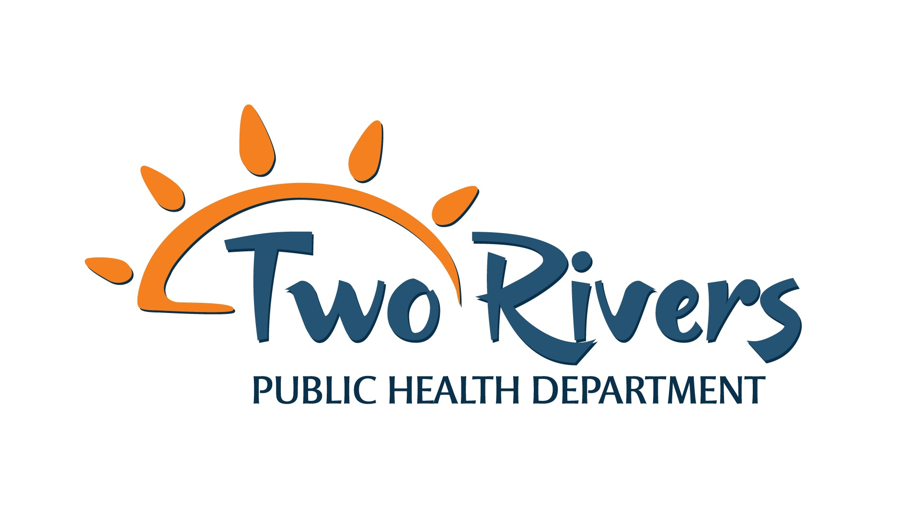
Public Health Nurse – RN Job Description

Job Title: Public Health Nurse - RN

Revised Date: August 20, 2024

Reports to: Clinical Section Manger or Designee

Scope of Authority: Exercises no supervision, oversees contract labor when needed.

Fair Labor Standards Act Status: Regular, full time, nonexempt, qualifies for overtime pay.

Security/Access: Employee will be issued picture identification and department credit card.

Job Summary: Responsible for a variety of assignments which include but are not limited to:
Responsible for planning and coordinating all aspects of a specific grant opportunity that targets the implementation of population-wide and priority population approaches to prevent obesity, diabetes, heart disease and stroke and reduce health disparities. Investigate communicable disease, investigate other issues of public health significance, and provide education on disease prevention activities. Conduct wellness screenings and provide targeted health and wellness promotion. Administer vaccinations and medication within scope of practice. Evaluate/assess health trends and risk factors of population groups through data collection and analysis, providing surveillance, tracking, reporting and follow-up on contagious diseases. Works with communities or specific population groups to develop/implement public policy. Participate in assessing and evaluating health care services to ensure that people are informed of available programs and services, provides health education, care management and primary care to individuals and families who are members of vulnerable populations and high-risk groups.

Required Education and Experience:
- Registered Nurse (RN) with current Nebraska license.
- Associate of Science in Nursing from an accredited college or school of nursing.
- National Incident Management System (NIMS) compliant within 6 months of employment.
- Proficient in Microsoft Office computer applications and data base applications.
- Ability to operate standard office equipment including but not limited to computers, printers, copiers, scanners, calculators, facsimile machines and telephone systems.
- Valid driver’s license and proof of personal driver’s insurance required. Ability to utilize own transportation for work purposes.
- Ability to travel within the TRPHD seven county service area. Further distances on occasion.
- Ability to work well with diverse groups in the public sector and demonstrate cultural awareness and sensitivity.

Preferred qualifications:
- Bachelor of Science in Nursing from an accredited college or school of nursing.
- One year experience working as a nurse in a program working in a community setting
- Experience as lead/charge nurse; experience in public or private agency
- Experience in implementation/oversight of program
- Experience in grant writing, program development, management, evaluation and fiscal management.
Duties and Responsibilities:
- Establish relationships with other Department and grant partners as applicable and set up schedule of meetings with grant staff or other community partners in person, through conference calls or via videoconferencing.
- Establish a timeline for completion of all activities in the grant and report to Director on progress of program goals and budget.
- Initiate program funder conferences, TA calls, workshops and trainings to expand knowledge of position and work with funders to communicate program goals and progress to other program partners. Work with Nebraska Department of Health and Human Services to determine what state, local and contractor resources and opportunities are available that could coordinate with district program needs.
- Plan, schedule and participate in necessary assessments with identified entities. Utilize results to strategically develop work plans and budgets to accomplish required goals of the programs. Work with the program staff and partners to develop individual training and program goals. Develop strategic timeline and work plan for program so that goals and roles are clearly defined for all partners and staff.
- Prepare quarterly reports on program goal progress, and progress toward improving outcomes for funder, partners and TRPHD Board of Health.
- Promote the programs’ purpose and goals among community and state contacts.
- Conduct communicable disease surveillance and containment activities in compliance with the State of Nebraska Department of Health and Human Services (DHHS) contracts, including phone interviews with clients, contact tracing when needed, computerized reporting, obtaining medical records, and seeking recommendations from DHHS and healthcare providers of clients.
- During influenza season, responsible for ILI Surveillance including weekly data collection and reporting to the State.
- Develop and conduct public presentations regarding varying topics related to public health, wellness and safety upon request.
- Provide referrals to appropriate community agencies and resources as needed.
- Identify barriers in health care access and assist in elimination of such barriers.
- Search for funding opportunities and develop, submit, and implement grants, budgets, and contracts with various funders.
- Demonstrate sound fiscal accountability.
- Comply with work plans, reporting requirements, and timelines per grant and/or contracts in an accurate and timely manner.
- Compliance with all TRPHD policies and procedures.
- Participation in assigned internal staff committees.
- Participation in required TRPHD trainings.
- Participate in performance management, activities to sustain a culture of QI within TRPHD and department accreditation efforts.
- Maintain strict confidentiality of sensitive information in accordance to HIPAA regulations.
- Represent TRPHD in a professional manner when out in the community in a variety of settings.
- Utilize cross-cultural communication skills to work with a wide range of populations and cultures.
- Assist with emergency response efforts to disease outbreaks and/or disasters when requested.
- Able to work some evenings and weekends as needed.
- Other duties as assigned.

Basic Skills and Abilities required:
- Ability to maintain an active and verified nursing license to practice nursing in Nebraska.
- Ability to assure continuing competency of nursing skills by meeting the continuing education requirements set forth by the State of Nebraska Department of Regulation and Licensure.
- Ability to establish and maintain effective working relationships with coworkers, administrative support organization, elected and appointed officials, representatives of other governmental units, private industry and members of the general public.
- Readily assumes responsibility.
- Ability to communicate effectively and articulate both orally and in writing.
- Ability to think strategically and exercise objective judgement.
- Ability to organize, analyze, and interpret technical information.
- Ability to organize tasks, establish priorities and meet established deadlines.
- Ability to sit, walk, stand and drive; use hands, fingers to handle or feel; reach with hands and arms; and talk and hear. The employee is occasionally required to stand, climb stairs, walk, stoop, kneel, crouch or crawl. The employee must be able to lift and/or move 50 pounds. Specific vision abilities required include those of close vision, distance vision, peripheral vision, depth perception and ability to adjust focus. The employee must be able to demonstrate physical fitness activities.
- Ability to work in a smoke/tobacco-free and drug-free work environment.

The position of Community Health Nurse requires a 30-day notice of termination.

I have read the above job description and agree to carry out the responsibilities described therein.

Employee: _______________________________________________ Date: ___________________

Director: _______________________________________________ Date: __________________

